Question & Answer Research (Animals)

MATERIALS:
- Can be downloaded for free here.
- Or make your own using the questions and answers below.
- Use the pictures from the animal Who Am I? Cards or any animal images you have available

Notes on the material (for adults):
- Sort the question and answer cards by color.
- Each category has a large question card and several smaller answer cards (The answers that have a slash here should have one word or phrase on one side of the card and the other word on the other side. Use the more common word or phrase when initially working with children and then you can turn over the card to discuss the new terminology.):

  - By what means do they move themselves?
    - by slithering, by walking, by hopping, by other means
  - In what element do they spend the most amount of time?
    - On the land/terrestrial, in the water/aquatic, in the air
  - What do they eat?
    - plants/herbivorous, animals/carnivorous, animals and plants/omnivorous
  - How do they reproduce?
    - by means of eggs/oviparous, born alive/viviparous, in other ways
  - How do they care for their young?
    - they take no care of their offspring, they provide food for their offspring, they suckle their offspring
  - In what climatic region do they live?
    - in very hot regions/torrid zone, in very cold regions/frigid zones, in regions which are neither hot nor cold/temperate zones
  - How do human beings regard them?
    - useful to human beings, harmful to human beings, neither useful nor harmful to human beings

EXAMPLE:
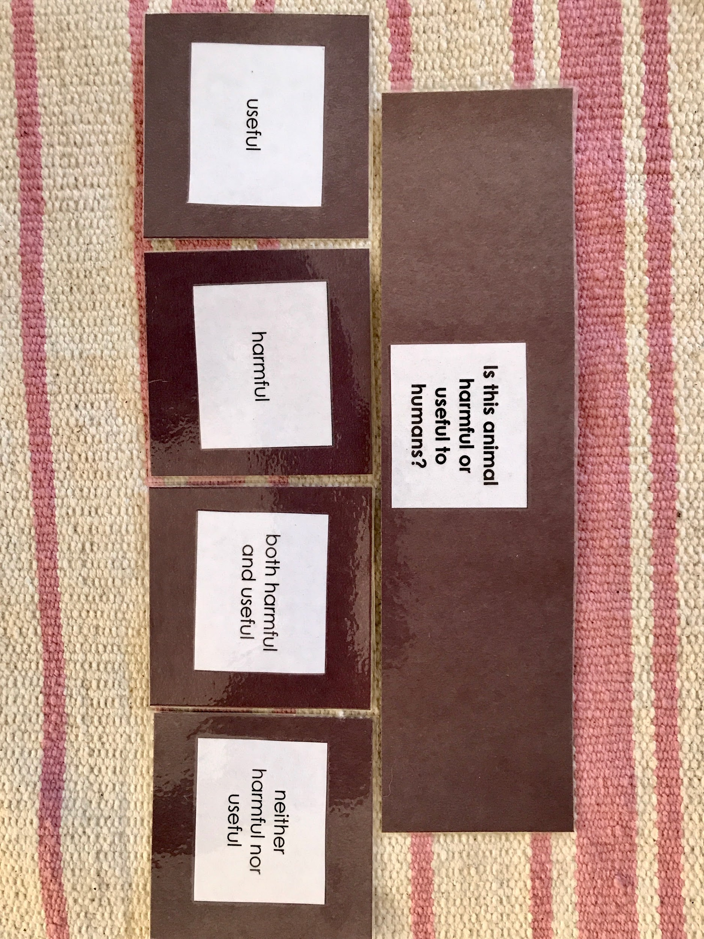

Notes:
- You should choose one animal and go through all the questions for that animal. Later, the children can choose one question and use it to categorize all the animals. The structured material allows them to make a structured report about a particular animal.

Hub VIP: Watch Animal Q&A Research Cards video here
(Access the videos and get 15% off a new Hub VIP membership with code GETVIDEOS - click here!)

PRESENTATION A: One Animal
- Connect with the Story of Life: Do you remember when we looked at the Timeline of Life? Over the millions and millions of years that animals have existed, did they always live in the same place? Did they all eat the same food? Do they all take care of their babies in the same way? No! Well, today we’re going to explore one animal in particular, and then you can explore your favorites!
- Invite the children to choose one animal from the Animal Story (Who am I?) cards.
- Lay out the question cards in a row across the workspace. Below each question card, put out the corresponding answer cards in small piles (color-coded).
- Choose a question and invite a child to read it out loud. Go through the possible answer cards with the children. The children can discuss and find the card that responds to the question correctly. Place the answer card below the question card and remove the ones that are not suitable.

Note: There can be more than one answer for some of the question cards.

- Then the children can follow the same process for all of the questions, discuss, and find the relevant answer cards.
- If the children have doubts, you can show them how to use an encyclopedia of animal life and help them to find the answers.
- When they’re done with all the cards for one animal, they can turn over the cards that have a synonym on the back. You can then discuss with them words like carnivorous, oviparous, temperate zones, etc.
- Next, you should order the cards with the children, inviting them to choose which to put first: what climatic region they live in, what they eat, how they move, where they live. (This can illustrate clear connections between the cards). Then they can choose how to organize: how they reproduce, how they take care of their offspring. The children should use reasoning. The last card should be: how do human beings regard them?
(see picture on next page)

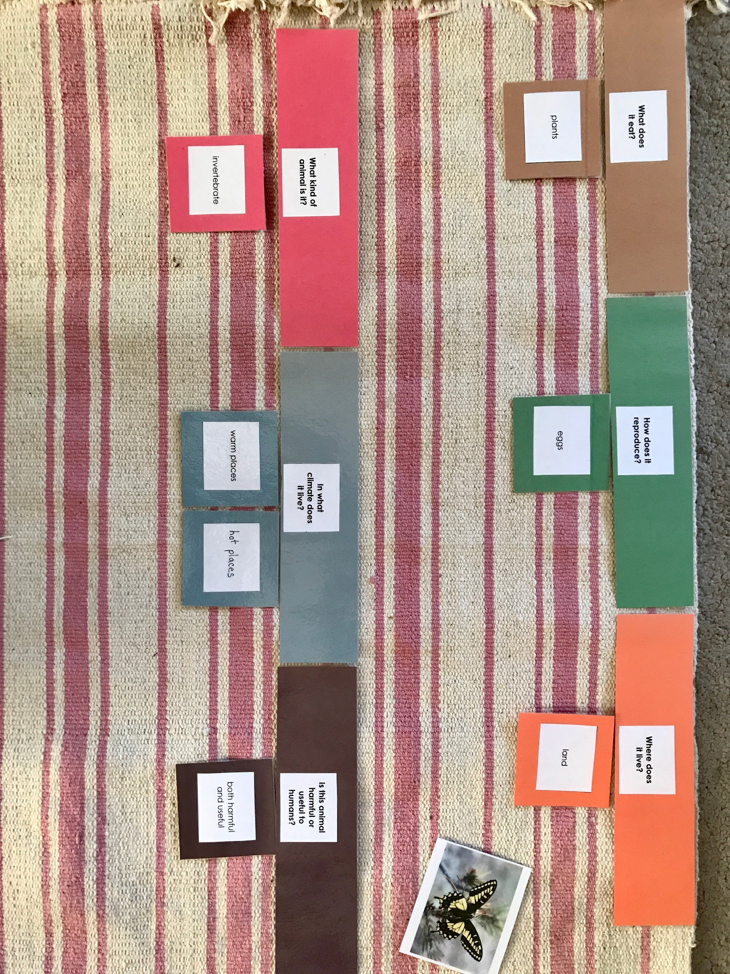
- When the children are done, they can use the cards to write about the animal in a systematic order. This material permits the children to write up very simple reports with self-guidance. They can also draw the animal or look for pictures in magazines.
- This is a great opportunity to point out the importance of pronouns. A young child might want to write/say: “The butterfly lays eggs. The butterfly drinks nectar. The butterfly…” You can ask: “What can we say instead of saying ‘the butterfly’ at the start of every sentence?”
- As an ambitious project, the older children can create an animal folder for each animal. Using each answer card as a starting-off point, the children can write more details (perhaps one page or card for each question/answer).

PRESENTATION B: One Question

- Lay out one question card at the top of the workspace. Below it, lay out the available answer cards that correspond to that question, in order to categorize all 46 animal cards.
- Go through each animal and choose what category it belongs to. If an animal satisfies more than one category, you can put that animal card between categories (example: platypus is semi-aquatic).

